THE SUN

The Sun is one of many millions of stars in the universe. It provides energy for Earth in the form of heat and light. This energy can be used for many things.

1. Plants use sunlight to make their food to grow by photosynthesis.
2. Animals need the light to see and the heat to keep warm.
3. The heat is responsible for the weather patterns over the Earth’s surface.
4. Photovoltaic cells convert sunlight into electricity.
5. Solar hot water heaters absorb the heat directly through black collection panels.
6. Houses can be designed to absorb maximum heat in winter and little heat in summer.

Characteristics
1. It is an extremely hot glowing ball of gas (15 million °C in the interior, 6000 °C on the surface).
2. Hydrogen is changed into helium and other elements by a thermonuclear reaction called fusion.

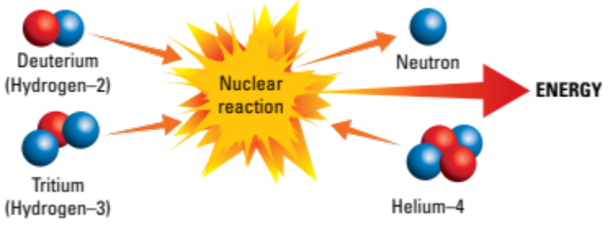
3. The Sun is 80% hydrogen, 19% helium, and the remaining 1% is heavier elements.
4. The hot gases exist as plasma - the fourth state of matter.
5. It is about 150 million kilometres from Earth and is 1 million times bigger in mass.
6. It is about half way through its life and will last for another 5000 million years.
7. Every second, 5 million tonnes of mass is lost, converted into energy according to Einstein's equation E = mc².
8. The large mass of the Sun (and other stars) generates a large gravitational force that squeezes the gases together, creating a large amount of heat and pressure. This generates the very high temperatures required for fusion to occur.

Radiations
1. Visible light - enables us to see.
2. Infra-red radiation - can’t be seen but is felt as heat.
3. Ultra-violet radiation - causes suntan and skin cancer; helps plants to grow.
4. Radio waves - picked up as “static” on radios.

Structure

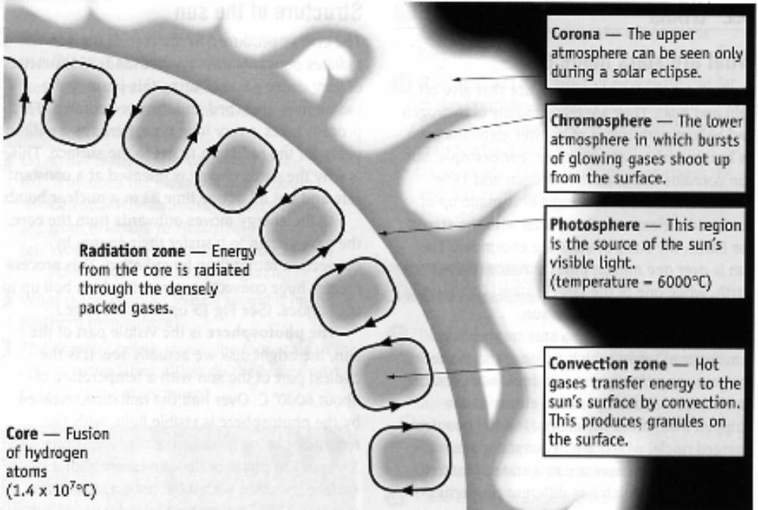

Core - thought by many to be made of iron and solid due to the immense pressure.

Photosphere - 300 km thick and made up of dense gas that gives the surface a "grainy" appearance. Is 6000 °C and produces most of the visible light.

Chromosphere - a thin pink-red layer that is only seen during eclipses.

Corona - upper atmosphere of 1 million °C that is clearly seen during an eclipse. Hot gases thrown out from this layer form the "solar wind" of charged particles that sweep outwards through space.

Sunspots
These are black spots that occur on the surface of the Sun at various times. The greatest number appears to occur in an 11 year cycle.

Sunspots are large eruptions that can last for a week or so. This causes an increase in the intensity of the “solar wind”, resulting in a disturbance to radio reception on Earth.

By observing the motion of sunspots across the Sun, astronomers have calculated that the Sun rotates once every 25 days at the equator and one every 34 days near the poles. This indicates that the outer layers are gaseous and not solid.

